PRESIDENT’S OFFICE
REGIONAL ADMINISTRATION AND LOCAL GOVERNMENT
LINDI REGIONAL COMMISSIONER’S OFFICE
FORM FOUR MOCK EXAMINATION
GEOGRAPHY
CODE NO.113 MAY, 2018
TIME: 3 HOURS
INSTRUCTIONS:
- This paper consists of sections A, B, C and D.
- Answer ALL questions in section A, B, C and one (1) question from each part of section D.
- Map extract of SONGWE RIVER sheet 244/3 is provided.
- Credit will be given for use of relevant sketch maps and diagram.
- Electronic or any other types of Calculator and Cellular phones are not allowed in the examination room.
- Write your examination number on every page of your answer booklet(s).

SECTION A: PHYSICAL AND MATHEMATICAL GEOGRAPHY (25 Marks)
Answer all questions in this section.

- For each of the items (i)-(x) choose the correct answer from among the given alternatives and write its letter beside the item number.
- ….. is the only planet in the solar system which it has the most number of
Satellites.
- Jupiter
- Neptune
- Saturn
- Mars
- Uranus
- When do we get the summer solstice in the southern hemisphere?
- 23rd September
- 21st June
- 22nd December
- 21st March
- 21st September
- An earthquake begins
- A long a fault or fissure
- At the inner core of the earth
- At the epicenter
- At the focus
- From the mantel layer
- The following is not a feature formed in the glaciated highland areas;-
- Truncated spur
- V-shaped valley
- Crag and tail
- Pyramid peak
- Arete
- The president Magufuli was addressing the nation at 09:00 pm in Dar- es- salaam (45°E)at a time Tanzanians in diaspora were streaming the speech live in England at 5:00pm.Find the Longitudes of England.
- 60⁰W
- 105⁰E
- 60⁰E
- 30⁰W
- 15⁰W
- The distance from source to the mouth of the river is called ;-
- Graded river
- Long profile
- Cross profile
- Upper section
- River capture

- Gneiss, Marble, Slate and Graphite are good example of;
- Porous rocks
- Permeable rocks
- Sedimentary rock
- Impermeable rock
- Metamorphic rock
- It occur when volume of air raising with the water vapour cool below the
temperature then saturate with moisture.
- Dew point
- Clouds cover
- Mist
- Evaporation
- Condensation
- Fold mountain are the results of;
- Tensional forces
- Compressional forces
- Faulting
- Depression
- Tilting
- Soil textures refers to
- Arrangement of soil particles
- Size of individual soil particles
- Soil catena
- Soil pH
- Grained structure

- Match the items in LIST A with the responses in list B by writing the letter of the correct responses besides the item number in the space provided.

LIST A |  | LIST B
i | Renewal of erosive power of the river | A | Erosion
ii | The zone of faults often develop into a valley | B | Seif dune
iii | A long narrow ridge of sand parallel to a wind direction | C | Rift valley
iv | Earth's zone which is rich in Nickel and Iron | D | Mantle
v | A large mass of ice flowing downhill in a valley under the influence of gravity | E | Glacier
 |  | F | Loess
 |  | G | River source
 |  | H | Core
 |  | I | Steep slope Landscape
 |  | J | River rejuvenation

- a) What is Mass wasting?
b) Explain five factors that influence the rate of mass wasting.
c) With the aid of diagram briefly explain three types of rapid mass wasting.
SECTION B: (27 Marks)
APPLICATION OF STATISTICS, INTRODUCTION TO RESEARCH
AND ELEMENTARY SURVEYING
Answer all questions in this section.

- a) Differentiate the following terms as used in statistics.
- Raw data and transforming data.
- Independent variables and dependent variables
- Discrete data and continuous data
- Study the following pie chart which show the exportation of cash crops of 100tonnes in year 2010.
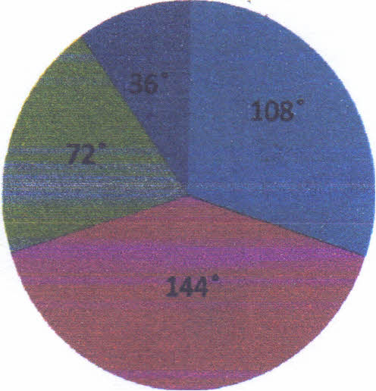

sisal
cotton
tea
cocoa
coca sisal

Tea
cotton

- From the data above ,construct a variable table
- Represent data in a simple line graph
- Mention the other method that may be used to present data above.

- a) What is meant by data as used in research?
- Differentiate primary data from secondary data
- Brief outline five stages followed in doing the research work and four obstacles someone can face when doing research.

- a) Define the term Levelling Survey.
- State four benefit of Leveling Survey.
- Explain four equipments used in Leveling Survey.

SECTION C: MAP READING AND PHOTOGRAPH INREPRETATION (28 Marks)
Answer all questions in this section

- Carefully study the map of Songwe river sheet 244/3 and then answer the following questions.
- Calculate the areas covered in km² in the Eastern part of the grid 095.
- Identify a place on the map by its name which located with forward bearing of 322⁰ and 17.5cm to a grid point 015185.
- Describe and then comment on population distribution
- With the concrete evidence from the map, give out five importance of the feature found on the North East of the Map sheet.
- Change the map scale into verbal scale.

- Carefully study the photograph provided below then answer the questions that follow;-

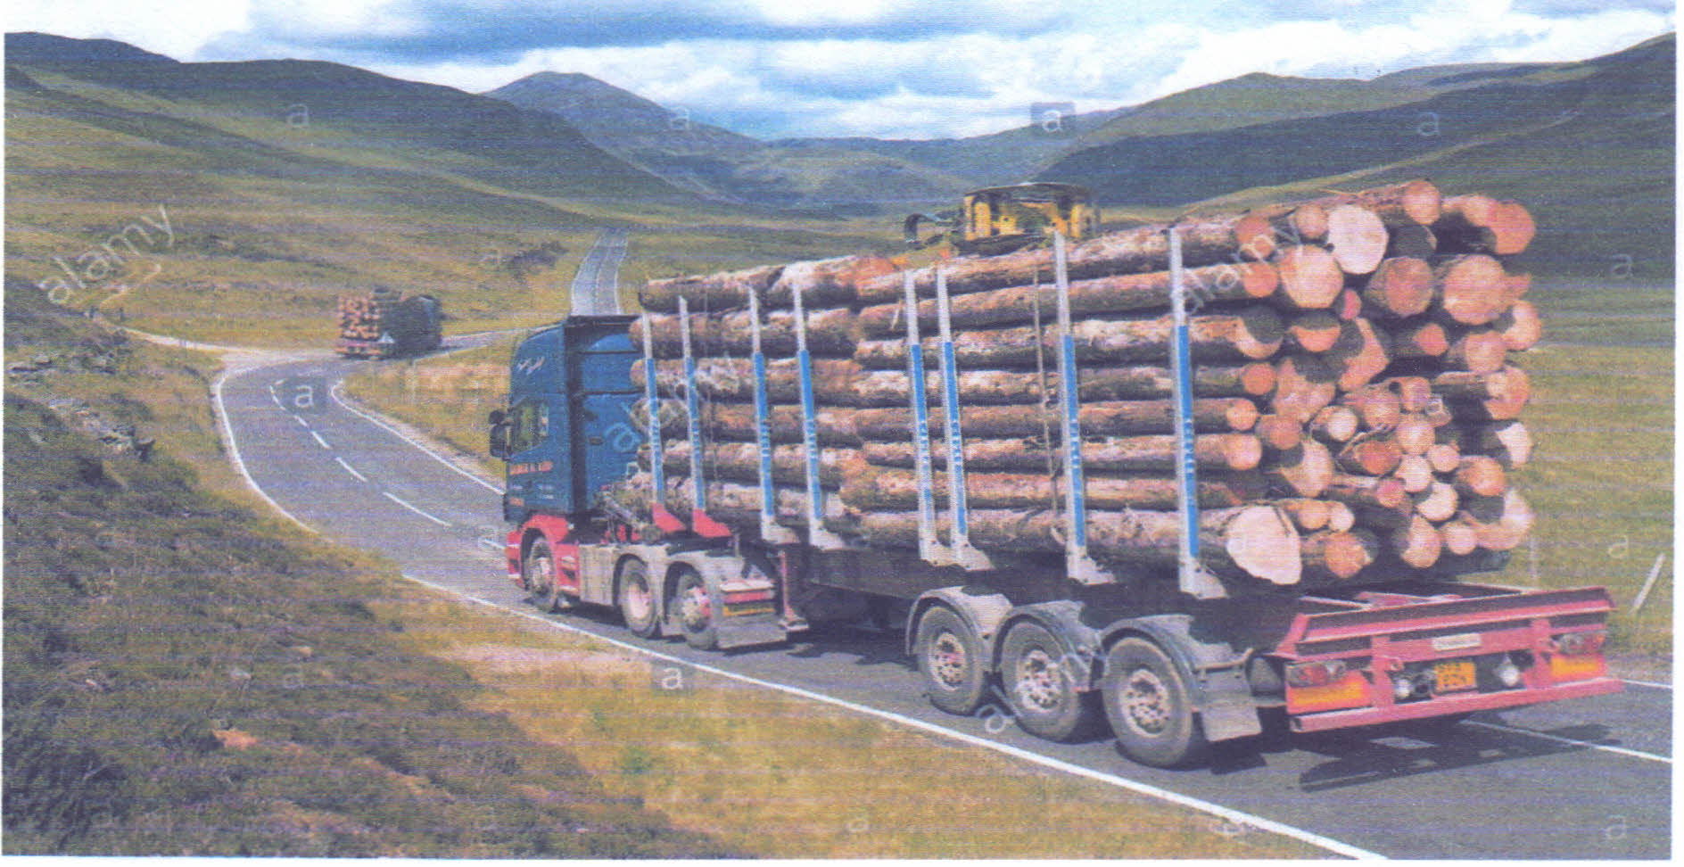

- Suggest the type of photograph by giving two reasons.
- Describe the activity on the photograph
- Identify the way used to obtain the resource that shown on the photograph
- Suggest three proper ways to reduce the impact lead by the process in question (c) above

SECTION D (20 Marks)
Answer one (1) question from each part
PART I: REGIONAL FOCAL STUDIES

- Why Western countries benefit from mining industry than developing countries (7 points).

- a) Tanzania has a great potential for Industrial development. Justify
b) Explain ways of improving the industrial base in East Africa.

PART II: ENVIRONMENTAL-ISSUES, POPULATION AND SETTLEMENT.

- With concrete examples, explain the factors for unevenly population distribution in Africa.

- a) What do you understand by the term Soil degradation?
b) In what ways can you combat soil degradation?

