LINDI MUNICIPAL COUNCIL
WEEKLY EXAM FORM FOUR JULY 2018

013 GEOGRAPHY

Time: 2.30 Hours
Instructions
1. This paper consists of sections A, B, C and D.
2. Answer all questions in sections A, B and C and one (1) question from each part of section D.
3. Map extract of MALAMPAKA (sheet 49/1) is provided..
4. Credit will be given for the use of relevant sketch maps and diagrams.
5. Calculators and cellular phones are not allowed in the examination room.
6. Write your Examination Number on every page of your answer booklet(s)

SECTION A (25 Marks)
Answer all questions in this section.
PHYSICAL AND MATHEMATICAL GEOGRAPHY
1. For each of the items (i) - (x), choose the correct answer from among the given alternatives and
write its letter beside the item number.
(i) Wadis, Bajada, Buttes and Mesa are examples of __________ features.
A. wind erosion and deposition B glacial erosion and deposition
C wave erosion and deposition D desert water erosion and deposition E river erosion and deposition
(ii) The Inter-Tropical Convergence Zone (ITCZ) means
A a region of low pressure B. a region of doldrums
C a region of high pressure D a sub-tropical high pressure belt E. a region with high speed winds.
(iii) Rias often provide natural harbour because they are
A found along the sub-merged coast. B mainly found in Europe where the sea is shallow
C deep outlets of water along the coast D not deep, ships can approach ports easily
E similar to lagoons but have shallow depths.
(iv) If the local time at town X (30°E 45°N) is 5.00 p.m. Monday, what will the time be at town Y (15°W 50°S)?
A 2 a.m. Monday B 8 p.m. Monday C 2 p.m. Monday D 3 p.m. Monday E 2 p.m. Sunday.
(v) The following are instruments used in chain and tape survey:
A Barometer, pegs, notebook, compass B Tape measure, chain, cross staff, anemometer
C Chain, arrows, ranging poles, altimeter D Arrows, ranging poles, pegs, chain
E Cross staff, notebook, chain and plane table.
(vi) When the river flows in its long profile it performs the following geological activities:
A Moves fast and can carry everything on the earth’s surface
B Erodes, transports and deposits weathered materials
C Meanders and forms ox-bow lakes throughout the profile
D Does three functions such as abrasion, solution and attrition
E Acts as agent of weathering and erosion along the profile.
(vii) If the location of a point on a map is given by grid reference 365490, then
A. 365 are Degrees B. 365 are Longitudes
C. 490 are Northings D. 490 are Eastings E. 365 are Northings.
(viii) Which of the following show the natural vegetation found in Tanzania?
A Coniferous, Mediterranean and mountains B Forest, tropical grasslands and thickets
C Temperate, tropical and deciduous grasslands D Savannah, equatorial grassland and tundra
E Tundra, maritime and grassland
(ix) The best major feature of the ocean floor for fishing activities is
A. continental shelf B. oceanic plain C. oceanic deep D. continental slope E. oceanic island.
(x) Landforms formed by vulcanicity can be divided into
A. Many parts according to the nature of lava B. Sills, dykes, valleys and earthquakes only
C. Volcanic mountains and sills only D. Extrusive and intrusive features
E. Batholiths, dykes and volcano only.
2. Match the items in List A with the responses in List B by writing the letter of the correct
response beside the item number.
List A | List B
(i) Intervisibility  (ii) A Basin  (iii) Glaciers  (iv) Denudation  (v) Stevenson’s screen | A. It determines the distance of a cross-section  B. Weather station  C. A catchment area of the river  D. Ox-bow lake  E. One of the sources of a river  F. A screen showing precipitation  G. Batholiths  H. Weathering and erosion  I. Movement of the earth  J. The ability to see between two given points

3. Soils may differ from one area but they share almost the same components. Describe the composition of the soil.

SECTION B (27 Marks)
Answer all questions this section.
APPLICATION OF STATISTICS, INTRODUCTION TO RESEARCH ANDELEMENTARY SURVEYING

4. Carefully study the data in the table below showing importation of motor vehicles from Europe in
2009, and answer the questions that follow:
Name of Motor Vehicle | Number of Motor Vehicle
JEEP | 430
BENZ | 192
BMW | 108
RIMOUSSENE | 70

(a) Draw a divided circle to represent the data.
(b) Show the disadvantages of the method you have used in (a) above.
5. (a) What is hypothesis formulation?
(b) Explain four importance of hypothesis in research.
6. (a) Mary is a good cartographer, she intends to produce a contoured map of Dar es Salaam.
What type of survey method would you advise her to apply?
(b) Apart from producing contour maps, what is the other significance of the type of survey you have mentioned in (a) above?

SECTION C (28 Marks)
Answer all questions in this section.

MAP READING AND PHOTOGRAPH INTERPRETATION
7. Carefully study the map extract of Malampaka (sheet 49/1) provided and answer the following questions:
(a) Calculate the area covered by seasonal swamps in Km 2 .
(b) Explain the distribution of natural vegetation.
(c) How long in kilometres is river Ng’hulu from grid reference 625496 to grid reference 700522?
(d) Identify any three ways which have been used to represent relief in the area.
(e) Through giving evidence, explain any four economic activities that might be taking place in the area.
8. Carefully study the following photograph and answer the questions that follow.

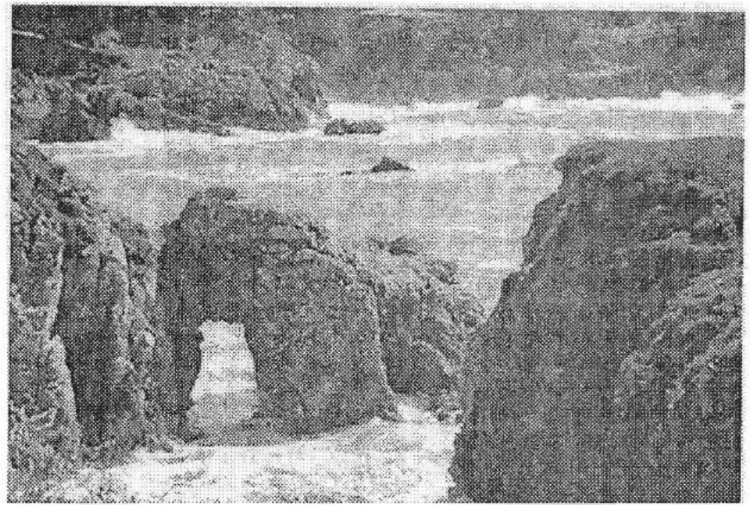

(a) Identify the type of photograph shown.
(b) Name three (3) features found on the photograph.
(c) How are the features named in 8(b) above formed?
(d) What are the economic importances of the features found on the photograph?

SECTION D (20 Marks)
Answer one (1) question from each part.
PART 1: REGIONAL FOCAL STUDIES

9. In order to achieve economic development, transport and communication are inevitable. Describe the significance of transportation in developing countries.
10. “Oil as an economic resource has improved the living standards of the people of Libya”. Discuss.

PART II: ENVIRONMENTAL ISSUES, POPULATION AND SETTLEMENT
11. Explain eight environmental problems related to the rapid population growth.
12. (a) Define the term ecosystem.
(b) What are the major causes of the loss of biodiversity?

