THE UNITED REPUBLIC OF TANZANIA
PRESIDENT OFFICE REGIONAL ADMINISTRATION AND LOCAL GOVERNMENT
LINDI REGION
FORM FOUR MONTHLY TEST FEBRUARY 2019
GEOGRAPHY

SECTIONA (25 MARKS)
PHYSICAL AND MATHEMATICAL GEOGRAPHY
- For each of the items (i) – (x) choose the correct answer from among the given alternatives and write its letter beside the items number.

- Which of the following is the proper arrangement of the first five planets of the solar system according to the distance from the sun starting with the nearest planet?
- Mercury, Earth, Venus, Saturn and Mars
- Mercury, Venus, Earth, Mark And Jupiter
- Venus, Mercury, Mars, Earth And Venus
- Mars, Earth, Mercury, Jupiter And Venus
- Mercury, Jupiter, Earth, Venus And Uranus

- If the time at place X, 45⁰E is 10:00, what will be the time at place Y,45⁰W?
- 6:00 am
- 10:00 pm
- 4:00 pm
- 4:00 am
- 10:00 am

- Which features forms a natural barrier to floods.
- Levee
- Dam
- Rapid
- Waterfall
- Delta

- An earthquake begins.
- Along a fault or a fissure
- At the inner core of the earth
- At the focus
- At epicenter
- From the mantle layer

- Which of the following features are produced by water action in desert area.
- Yardages and playas
- Sand dune and canyons
- Alluvial fans and Zeugens
- Canyons and playas
- Alluvial fans and sand dunes

- Reverse fault is mainly caused by.
- Earth movement
- Tension force
- An earthquake
- Weathering
- Compressional force

- The part of the earth forms continental blocks is called
- Sima
- Core
- Mantle
- Sial
- Hydrosphere

- The temperature of Dar Es Salaam at sea level is 310C. What will be the temperature of Arusha 2500 metre above sea level?
- 16⁰C
- 29⁰C
- 15⁰C
- 46⁰C
- 32.5⁰C

- The slow movement of soil particles which can be recognized by bending of trees and fences is referred to as
- Land slide
- Mud flow
- Soil creep
- Rock fall
- Soil erosion

- Which one among the following features occurs in glaciated lowland region.
- Esker
- Cirque
- Pyramidal
- Hinging valley
- Arête

- Match the phrases in List A with the responses in List B by writing the letter of the correct response beside the item number.
- The galaxy from which the Solar system containing the planet earth is found. | - Atmosphere
- A large area on the earth surface with uniform characteristics of temperature rainfall and vegetation. | - Ozone layer
- A thin blanket of air surrounding the earth. | - Compressional force
- A process that cause the wrinkling of the earth surface rocks | - Tension force
- The destruction of rocks by temperature change. | - Milky way
 | - Andromeda spit
 | - Weathering
 | - Erosion
 | - Natural region
 | - Equatorial climate

- (a) Using the knowledge you have studied on rivers define river capture
(b) With the use of well labeled diagrams, describe the features resulting from the river capture.

- (a) What is divergence line graph.
(b) Construct divergence line graph to show the trend of coffee production in Tanzania from
2010 – 2014.

Year | 2010 | 2011 | 2012 | 2013 | 2014
Coffee production 000⁰ tones | 2050 | 2600 | 1800 | 1950 | 300

(c) Outline three (3) Merits and two (2) Demerits.

- (a) What is research design?
(b) Explain any four (4) types of research design.

- (a) (i) Define the term levelling survey.
(ii) State four (4) benefit of Levelling survey

(b) Explain five (5) essential equipment used in levelling survey.

SECTION C (25 Marks)
MAP READING AND PHOTOGRAPH INTERPRETATION

- Carefully study the of MALAMPAKA provided then answers the questions that follow.
- Name the types of scale used to constructs the Map.
- Calculate the distance of River Ndala from grid reverence 55647 to grid reference 598496.
- With evidence from the Map suggest any three economic activities and two social activities that can took place in the area shown.
- With evidence from the map mention the major types of transport shown in the area.
- Calculate the area covered by second Swamps in Km²

- Study carefully the photograph provided below and then answer the question that followers.
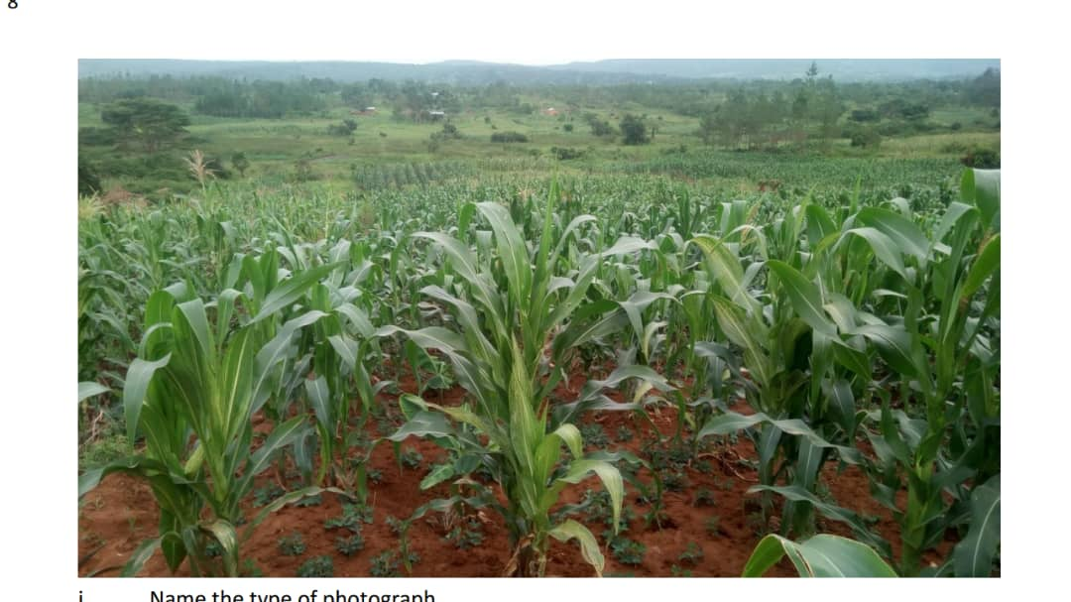

- Name the types of photograph (Give two reason)
- (i) Identify the types of Crops shown on the photograph.
(ii) Give necessary conditions for the growth of the crops shown. (3 point)

- (i) Comment on the scale of production.
(ii) Give in the stage of which crops shown might have seen reached

- Name any two possible areas in eastern Tanzania where the crops is grown.

SECTION D
Answer one 1 question from each part
PART I: REGIONAL FOCAL STUDIES (20 Marks)

- Despitehaving many water bodies, East Africa has not managed to develop advanced fishing industry. Discuss.

- Discuss the low level of industrial development in developing country.

PART I:ENVIRONMENTAL ISSUES, POPULATION AND SETTLEMENT
- Explain eight environmental problems related to the rapid population growth.

- Examine eight (8) factors which lead to the growth of settlement in different part of a country.

“All the best”

